FACILITY: Delta Solid Waste Management Authority | SRN / ID: N6035
LOCATION: P.O. Box 198, 5701 19th Avenue North | DISTRICT: Marquette
CITY: Escanaba | COUNTY: Delta
CONTACT: David Lundquist | EVALUATION END DATE: July 24, 2025
STAFF: Drew Yesmunt | COMPLIANCE STATUS: Non-Compliance
EPA Class: Major

Facility: Delta Solid Waste Management Authority (SRN: N6035)
Location: 5701 19th Avenue North, Escanaba, MI 49829
Contact(s): Dave Lundquist, Operations Manager; Terri Rabitoy, Administration Manager

Regulatory Authority
Under the Authority of Section 5526 of Part 55 of NREPA, the Department of Environment, Great Lakes, and Energy may upon the presentation of their card, and stating the authority and purpose of the investigation, enter and inspect any property at reasonable times for the purpose of investigating either an actual or suspected source of air pollution or ascertaining compliance or noncompliance with NREPA, Rules promulgated thereunder, and the federal Clean Air Act.

Facility Description
Delta County Landfill is a municipal solid waste (MSW) landfill owned by Delta Solid Waste Management Authority (DSWMA) and the City of Escanaba. The landfill covers 277.9 acres and is located in Wells Township, Delta County, Michigan. The source is in a rural setting approximately 2.5 miles NW of Escanaba and is surrounded by undeveloped forests and wetlands. A sports club located to the east is the nearest developed property.

Delta County Landfill is classified as a Type II sanitary landfill. The Southern Landfill has been closed since July 26, 2016. The Northern Expansion began accepting waste May 18, 2015, and is the current active area. There are two closed Type III landfills which contain construction demolition waste and fly ash. The Type III cells are not subject to the requirements of the NSPS or NESHAP for Municipal Landfills or Part 70 permitting.

On July 9, 2009, EGLE, Materials Management Division, sent DSWMA an approval for a construction expansion permit (Northern Expansion). The proposed landfill expansion increased the maximum design capacity of the landfill site from 1.65 million cubic yards to 7.85 million cubic yards. Since the landfills design capacity exceeds 2.5 million cubic meters, the stationary source is subject to Title 40 of the Code of Federal Regulations (CFR) Part 70 requiring a Title V renewable operating permit.

Actual NMOC emissions at Delta County Landfill exceed 34 Megagrams per year, thus the landfill maintains an active gas collection control system (GCCS) with an open flare as a control device at both the North Landfill and the closed South Landfill. The South Landfill collection system and flare were completed and started on October 1, 1998. On March 26, 2020, the North Landfill gas collection system was installed and the flare was started.

Process Description
A landfill consists of an area of land or an excavation in which wastes are placed for permanent disposal. The process begins with collected waste being transported to the landfill where it is dumped into an area (cell). A synthetic liner, such as high-density polyethylene, is used at the bottom to prevent contamination of leachate and landfill gas with ground water and soil. Heavy equipment then spreads the waste, compacts it, covers the waste with soil or alternate daily cover materials (ADCM), and further compacts it on a daily basis. When a cell is full, it is covered permanently with a liner cap and compacted soil.

Emissions
Landfill gas is generated through bacterial decomposition of organic materials contained in solid waste. Initially, decomposition is aerobic until the oxygen supply is exhausted. With the solid waste being insulated from the atmosphere, decomposition then occurs anaerobically producing most of the landfill gas. Landfill gas (LFG) consists of approximately 50% methane, 50% carbon dioxide, and less than 1% non-methane organic compounds (NMOC). The NMOC fraction consists of various organic hazardous air pollutants (HAP), greenhouse gases, and volatile organic compounds (VOC).

LFG can be collected through one of two methods: active and passive gas collection systems. Delta County Landfill has an active collection system. There are 21 wells on the south landfill and 3 at the north. 4 of the wells on the south landfill are shut off. Each landfill also has an active open flare.

Emissions Reporting
Delta County Landfill is a Title V major source and is required to report its annual emissions to MiEnviro. The following table lists the source total emissions for the reporting year 2024.

Pollutant | Emissions (TPY)
CO | 100.80
PM10-PRI | 2.34
PM2.5-PRI | 2.33
NMOC | 55.37
NOX | 5.39
SO2 | 1.12
VOC | 0.75

Regulatory Analysis
The facility is permitted under MI-ROP-N6035-2022. The facility is subject to 40 CFR Part 62, Subpart OOO for MSW Landfills that commenced construction on or before July 17, 2014, and have not been modified or reconstructed since July 17, 2014. In addition, the stationary source is subject to Title 40 of the Code of Federal Regulations (CFR) Part 70, because its design capacity exceeds 2.5 million Mg and 2.5 million cubic meters. Actual NMOC emissions at Delta County Landfill exceed 34 Megagrams annually (Mg/yr), therefore the landfill has an active GCCS with an open flare as a control device at both the North Landfill and the closed South Landfill.

EULANDFILL, EUACTIVECOLL, EUOPENFLARENORTH, and EUOPENFLARESOUTH at the stationary source are subject to the National Emission Standard for Hazardous Air Pollutants for MSW Landfill promulgated in 40 CFR Part 63, Subparts A and AAAA.

The facility is subject to the asbestos regulations found in 40 CFR Part 61, Subparts A and M, because the facility accepts asbestos containing waste.

Compliance History
DSWMA has received three violation notices in the last five years. In December 2022, upon inspection, the facility received a violation notice for the following violations: inadequate warning signs for asbestos (EUASBESTOS, SC III.1), asbestos was not being covered at the frequency required in SC III.1.c or daily Method 22 readings for 15 minutes were not being performed and recorded (EUASBESTOS, SC III.1), a map of the location of asbestos in cell 6 was initially not available (EUASBESTOS SC VI.2), the facility was not keeping records on all fuels combusted in the furnace on an hourly basis or observing and recording daily visible emissions (EUFURANCE1, SC VI.2, 3), SEMS data was not being properly reviewed with exceedances documented and exceedance procedures followed (FGLANDFILL-AAAA, SC V.3, VI. 1, VII.4). The violations were addressed and considered resolved on 3/14/23.

The facility was inspected again in May 2024 and received a violation notice for the following violations: asbestos was not being covered at the frequency required in SC III.1.c or daily Method 22 readings for 15 minutes were not being performed and recorded (EUASBESTOS, SC III.1), and records of the amount and type of material that has been used to cover the asbestos waste and documentation that the cover material was applied in the frequency required in Special Condition III.1.c were not available (EUASBESTOS, SC VI.4.b). In the response to the violation notice, the facility stated that the asbestos waste observed during the inspection was unintentionally uncovered during regrading of the asbestos waste area. A violation notice was then sent to the facility for disturbing asbestos waste deposited in the North landfill without sending written notification to the AQD Technical Programs Unit and Marquette District Office at least 45 days prior. These violations were considered resolved on October 28, 2024, upon inspection where AQD staff observed ACWM was covered and records of covering activities were provided. However, breaks in cover were observed, demonstrating a need for cover checks and recovering. AQD staff requested that the facility performed daily checks of cover, recovering as necessary, and maintain records of all checks and recovering activities performed.

Inspection
On July 24, 2025, AQD Staff (Drew Yesmunt) conducted an unannounced inspection of DSWMA. AQD Staff arrived at the office building and met with Operations Manager, Dave Lindquist. It was explained that the purpose of the inspection was to ensure compliance with MI-ROP-N6035-2022 and all other applicable air pollution control rules and federal regulations. The inspection began with a tour of the landfill. The inspection concluded by discussing records and operations. Following the on-site inspection, records were requested and received via email. Waste is currently being deposited in cells 6a and 6b. Cell 5 was the first cell in use at the North Landfill. Cell 5 is not yet capped. The South Landfill is closed and consists of cells 3a, 3b, 4a, and 4b.

FGLANDFILL-OOO
The landfill has an active gas collection control system (GCCS) with an open flare as a control device at both the North Landfill and the closed South Landfill (SC IV.1 and 2). As required under Special Condition VI.1, design capacity records were requested. The total current design capacity is 8,289,006 cubic yards. Delta County Landfill is also required to monitor and record the amount of waste brought in on a year-by-year basis and the current amount of waste in place. As of September 30, 2024, there was 566,694 cubic yards of waste in place in the North Landfill. The South Landfill has 1,827,458 cubic yards of waste in

place. For 2024, the facility received a total of 34,524 tons of municipal solid waste. For January 2025 through June 2025, the facility received 17,838 tons of municipal solid waste.

The facility has been prompt in submitting their annual and semiannual certification of compliance for MI-ROP-N6035-2022. The facility also submits gas collection parameter monitoring reports, methane surface monitoring reports, SSM incident reports, flare downtime reports, and gas collection downtime reports.

FGLANDFILL-AAAA
The facility is required to complete quarterly surface emissions monitoring survey (SEMS) for methane (SC V.1, SC VI.1). Quarterly SEMS were most recently performed on 03/03/2025 and 06/27/2025. There were no records of exceedances of 500 ppm over background level during the quarterly SEMS (SC V.3). The facility is using a SEM5000 to complete the surface emissions monitoring (SC V.4). A map was provided to show the area traversed during the SEMS, and meteorological data was provided for the day of testing (SC VI.1). Landfill cover is 6-8 inches of sand mixed with paper mill sludge if it is available. Records of cover integrity were provided from January 2024 through July 2025 showing weekly cover monitoring checks and noting any repairs made to the cover. During the reported period, the facility documented no issues in cover integrity (SC VI.2). The facility has been prompt in submitting their annual and semiannual certification of compliance for MI-ROP-N6035-2022 (SC VII.1,2). The reports have not included any documentation of exceedances of 500 ppm during the SEMS surveys (SC VII.3).

FGACTIVECOLL-OOO
The landfill has an active gas collection control system (GCCS) with an open flare as a control device at both the North Landfill and the closed South Landfill (SC IV.1,3). The current maximum expected gas flow rate is 196 ft³/min from the North Landfill and 250 ft³/min from the South Landfill (SC IV.1). The facility provided complete landfill gas system records and as-built documents for the North Landfill and a map of the wells located at the South Landfill (SC VI.2-4).

The facility has been prompt in submitting their annual and semiannual certification of compliance for MI-ROP-N6035-2022. (SC VII.1,2)

FGACTIVECOLL-AAAA
The landfill has an active gas collection control system (GCCS) with an open flare as a control device at both the North Landfill and the closed South Landfill (SC III.1). The South Landfill collection system and flare were completed and started on October 1, 1998. On March 26, 2020, the North Landfill gas collection system was installed and the flare was started. The collection system must operate with negative pressure at each wellhead (SC III.2). The landfill reported no deviations from negative pressure in their most recent semi-annual (07/01/2024-12/31/2024) report. Monthly well monitoring records (January 2023-May 2024) were provided that show numerous readings including temperature, methane, carbon dioxide, and oxygen. All temperatures were below 145 degrees Fahrenheit (SC III.3, SC IV.3, SC VI.3, SC VI.6, SC VI.7, SC VI.8, SC VI.10, SC VI.11). The facility also provided maps showing the collection system wells for both the North and South Landfill (SC VI. 10,11).

The facility has been prompt in submitting their annual and semiannual certification of compliance for MI-ROP-N6035-2022 and included periods of startup, shutdown, and malfunction within those reports (SC VI.8,9 & VII.1,2). For 2024, the facility reported a deviation where the north landfill flare was down

from 11/08/2024 to 11/20/2024 due to blower motor failure. This failure resulted in the facility missing the monthly wellhead reading for three wells. During the inspection, the facility stated that the monthly checks would occur at the beginning of the month to avoid similar deviations in the future.

FGOPENFLARE-OOO
The landfill has an open flare at both the North and South Landfills. There were no visible emissions during the inspection (SC I.1). A flame was present at the north flare during the inspection. No flame was present at the south flare at the time of inspection. The facility explained that the flare was automatically shut off due to thermocouple failure, and the flare and gas flow would be restarted once the thermocouple was replaced (SC III.2). The flares were tested in accordance with the regulation on 9/19/2022. No visible emissions were observed from either flare during the testing (SC V.3). The net heating value of gas being combusted was determined to be 476.6 BTU/ft³ for the North Landfill and 291.1BTU/ft³ for the South Landfill. The exit velocity for the North Landfill flare was determined to be 1.84 feet per second and the South Landfill flare was 6.93 feet per second (SC V.2).

FGOPENFLARE-AAAA
Both flares are equipped with a heat sensing device and a device that records gas flow (SC IV.2, 3). At the time of the inspection, AQD observed the north flare had a gas flow of 36 CFM. The south flare had no gas flow due to thermocouple failure. As stated above, both flares were tested in accordance with the regulation on 9/19/2022 (SC V.1-4). Both flares are maintained regularly, malfunctions are recorded, and temperature and flow are recorded. Records were provided for June 2024-June 2025. (SC VI.2)

The facility has been prompt in submitting their annual and semiannual certification of compliance for MI-ROP-N6035-2022 (SC VII.1,2).

FGCOLDCLEANERS
There are currently no cold cleaners in use at the facility and no plans to begin using one. The cold cleaner has been empty and unused since 2018.

EUASBESTOS
During the tour of the landfill, asbestos warning signs were observed along the perimeter and at the entrances to the landfill (SC III.1). The regulation requires that, unless meeting the no visible emissions requirement, a cover of at least 6 inches shall be applied at the end of each operating day or at least once every 24-hour period while the site is in continuous operation (SC III.1). The facility has received multiple violation notices from the previous two full compliance evaluations for not meeting this requirement. During the landfill tour, bags of asbestos were visible and not covered. Waste shipment records were reviewed and asbestos was last accepted on 7/22/2025. This would mean the asbestos has been uncovered for a period of over 24 hours. It was relayed to landfill staff that asbestos was uncovered during the tour which is a violation. Records on the amount and type of material used to cover the asbestos were provided (SC VI.4). During the previous inspection of EUASBESTOS in October 2024, the landfill had provided pictures documenting cover activity for the asbestos waste area and stated that daily cover checks would be instituted to ensure cover is maintained over asbestos waste. These records were not provided upon request.

Delta County Landfill keeps records of the name, address, and phone number of the waste generator and transporter for each shipment received on the Waste Shipment Record form. The quantity of the

asbestos-containing waste material is also recorded (SC VI.1). Copies of the Waste Shipment Records and receipts were provided. Asbestos is currently disposed of at one location in Cell 6. Asbestos location maps were provided for both the North and South Landfill (SC.VI.2).

EUFURNACE1
The facility has a 250,000 Btu/hr clean burn multi-oil furnace in a shop building. Visible emissions from the furnace shall not exceed 10% opacity (SC I.1). During the inspection, the furnace was not operating. Records were provided on visible emission checks during operation of the furnace for calendar year 2024. No issues were documented (SC VI.3). The facility submits a waste oil sample for analysis annually. A waste oil analysis from June 2024 was provided and all materials were within the permitted limits. Waste oil burned in the furnace is generated both on-site and off-site (SC.III.1, SC V.1). The furnace is equipped with an hour meter, and monthly fuel usage and hours are tracked to monitor flow. Records were provided on fuel usage for June 2024-July 2025 (SC VI.1,2). The furnace stack appeared to be at least 25 feet above ground (SC.VIII.1).

Compliance
Based on the inspection performed and records reviewed, Delta County Landfill does not appear to be in compliance with MI-ROP-N6035-2022. During the on-site inspection, asbestos was observed not being covered at the frequency required in SC III.1.c or daily Method 22 readings for 15 minutes were not being performed and recorded (EUASBESTOS, SC III.1). A violation notice will be issued in response.

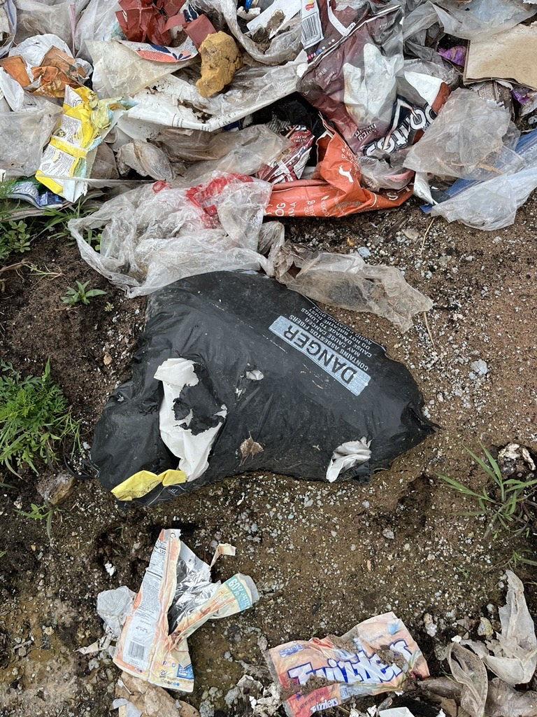
Image 1: Uncovered asbestos
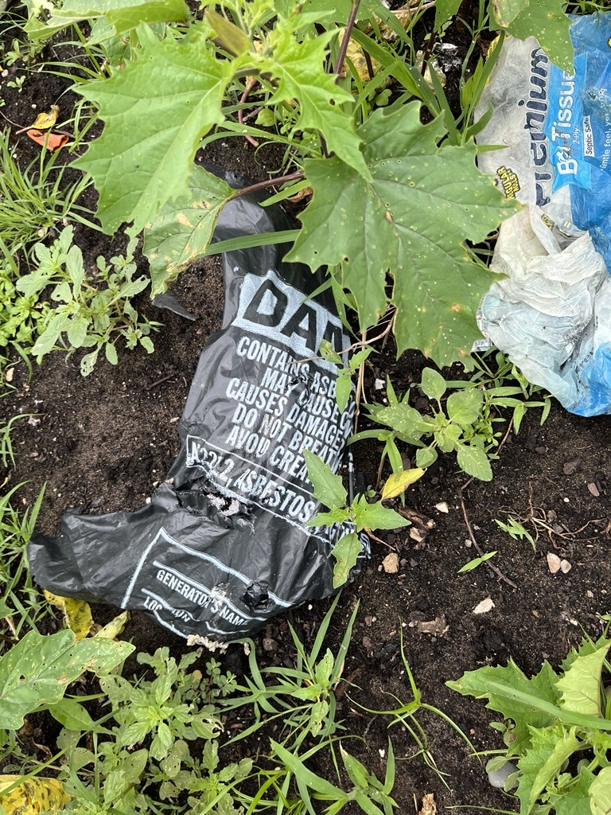
Image 2: Uncovered asbestos
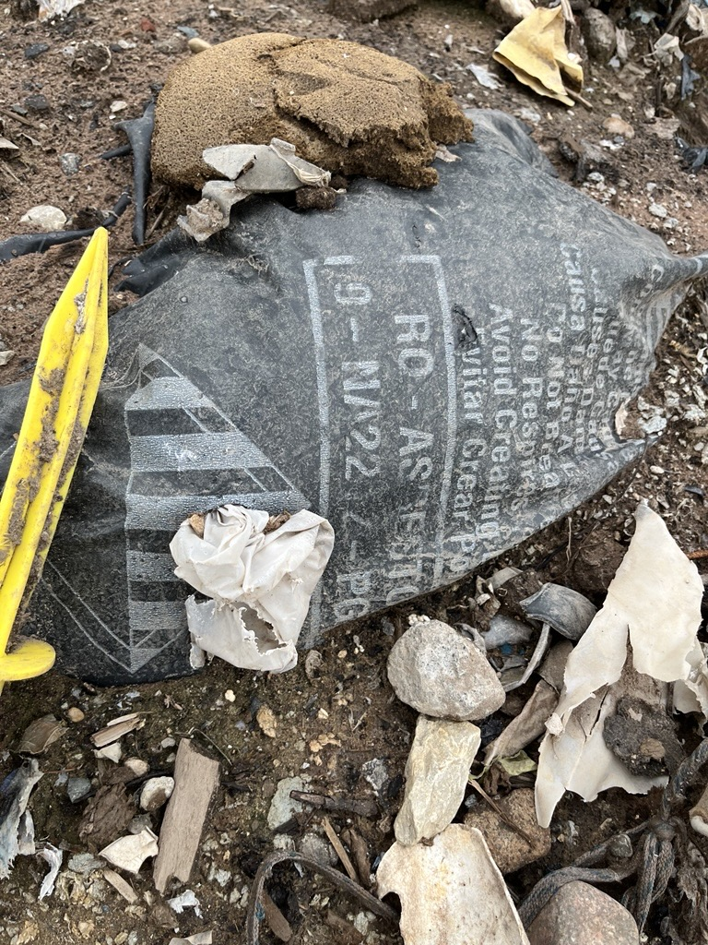
Image 3: Uncovered asbestos
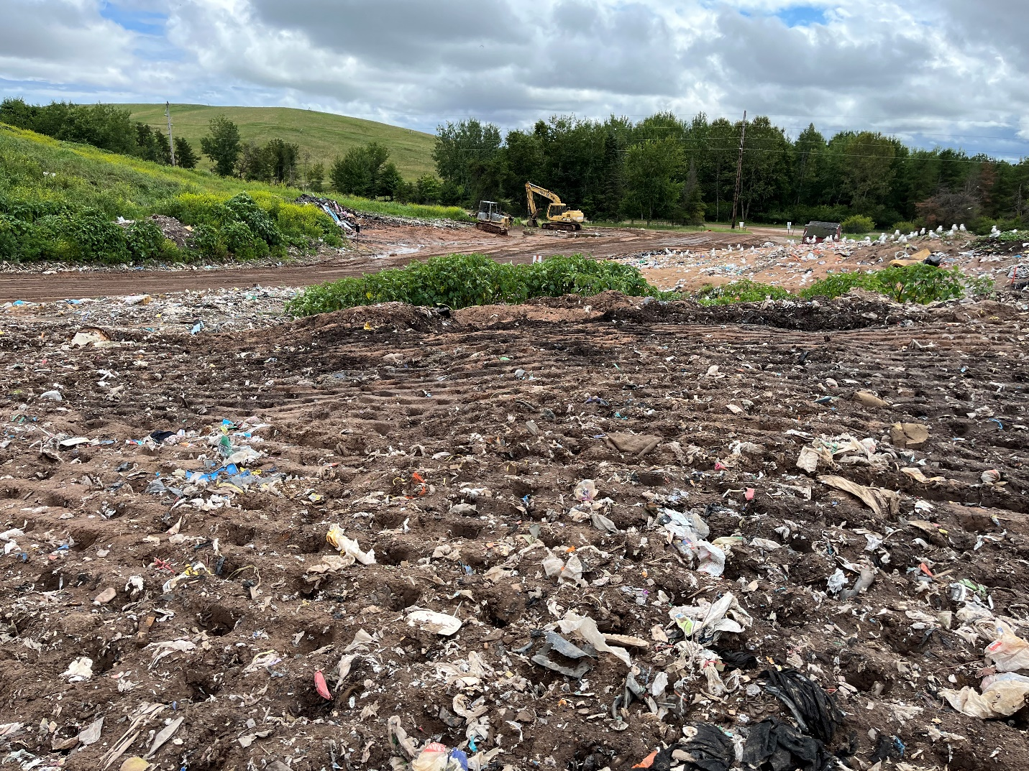
Image 4: Asbestos waste area

